CIS 150 – Lab 9

Dr. Brahim Medjahed
Due date: November 17, 2014
Labs returned after the due date will not be accepted

Question 1 (20 points)

Let us a consider program that contains the following array declaration:

const int SIZE = 10;
int ages [SIZE] = {18, 17, 21, 25, 18, 19, 27, 18, 20, 22};

The array contains the ages (positive integers) of students in a class of size SIZE.

Write a program that determines and displays the age of the oldest and youngest student in the class. Your program should work for any value of SIZE and any positive integer contained in the array

Question 2 (20 points)

Consider a structure Student with data members: id (a string) and score (a float) as follows:

struct Student
{
string id;
float score;

};

Write a program that creates an array of 4 students. The program should then use a for loop to populate the array with values entered by the user (using cout and cin). The program finally displays the average score.

Question 3 (20 points)

Consider the program your wrote in question 2 of Lab 8. Modify the program to implement the following:

- Add a function named instructions(). The function should be called at the beginning of the main program to display instructions to users such as what the program does and how to use it.
- Add another function named ending(). The function should be called at the end of the main program to simply thank users for using the program.
- Instead of asking users to enter the Student ID and student answers from the console, assume that student answers are all stored in a text file named “answers.txt”. Each line contains a student ID followed (in the same line) by a string of characters representing the answers of that student. The student ID and answers are separated by one or more spaces. Below is an example of file that contains the ID and answers of 3 students (one per line). Note that your program should work for ANY number of students and ANY answer. Each line corresponds to one student.

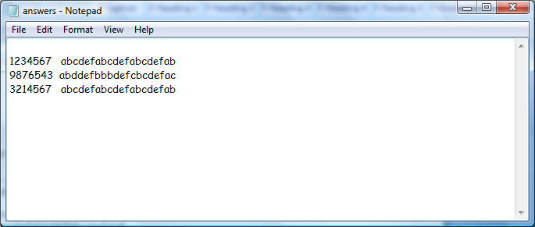

Submission of Your Work

You need to prepare ONE SINGLE MS word document report (with the name YourLastName_Lab9) that contains:

- For question 1: include 1 screenshot and the source code.
- For question 2: include 1 screenshot and the source code.
- For question 3: include 1 screenshot and the source code.

Important:
- Make sure you display appropriate messages to users during the execution.
- Make sure you properly format your MS word document report

Upload the file to Canvas (in the lab section) under Lab9 assignment.

